**To Create A New Profile:**

1. Go to setup >> type profiles in quick find box >> click on profiles >> clone the desired profile (standard user is pref

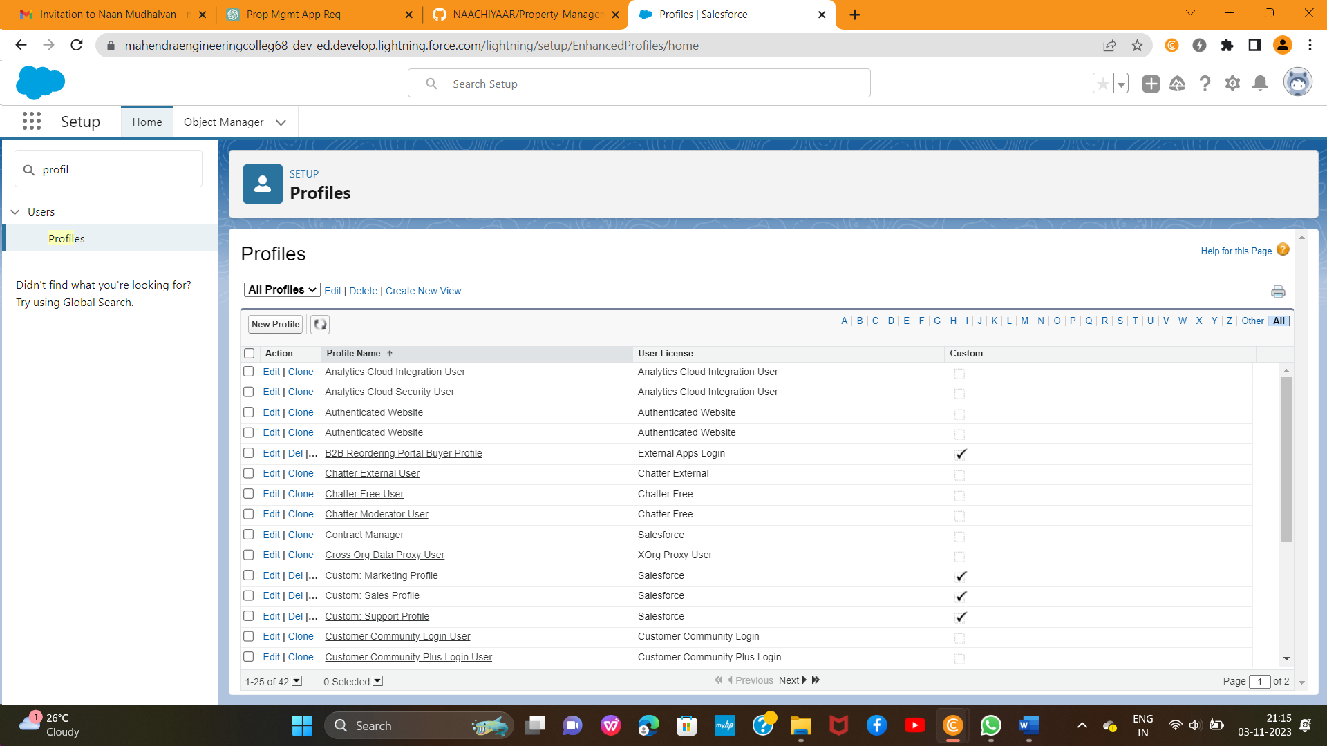

2. Enter a Profile Name(Sales Manager) And click on Save

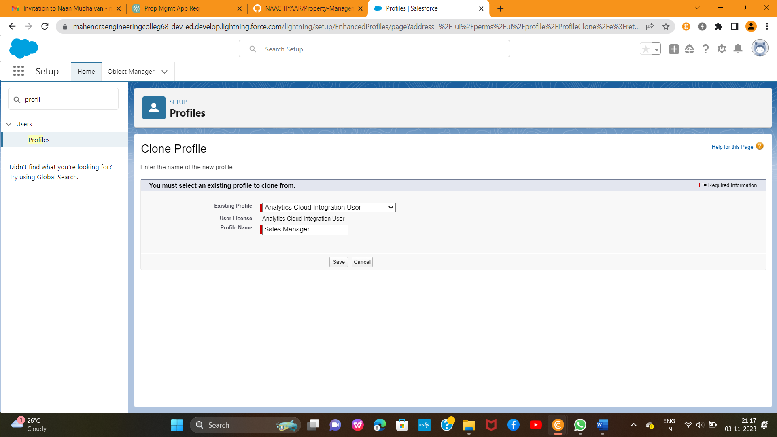

3. Click on the new created profile

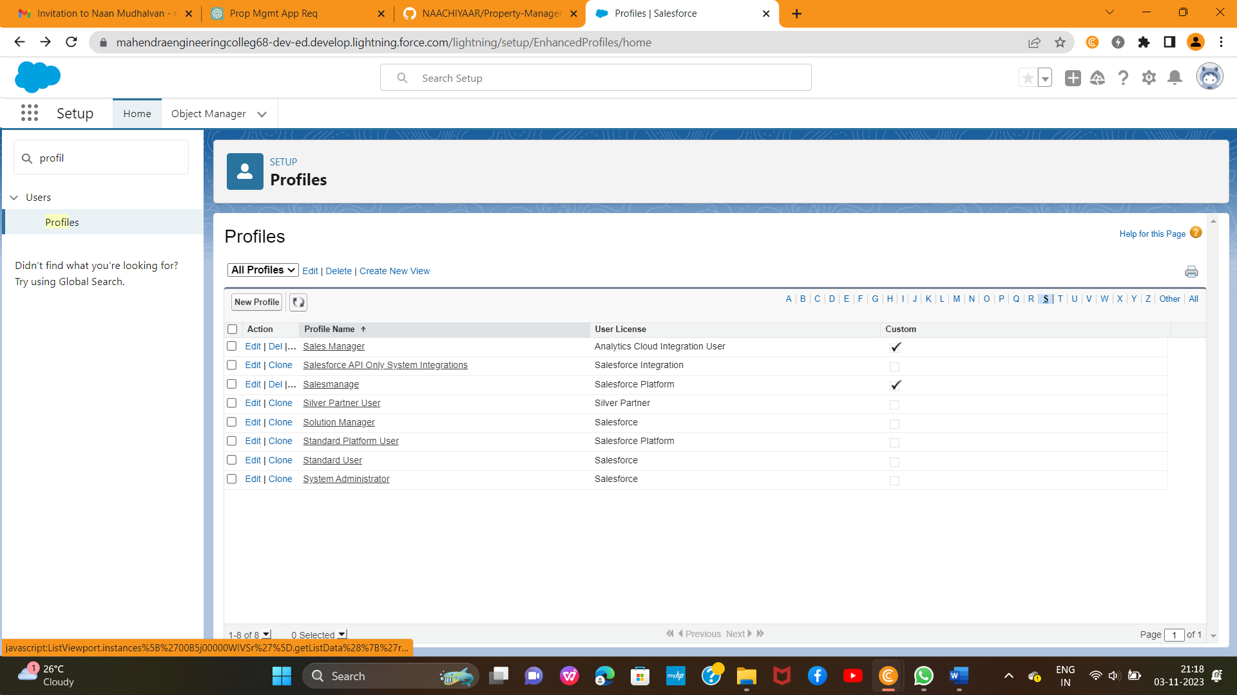

4. While still on the profile page, then click Edit

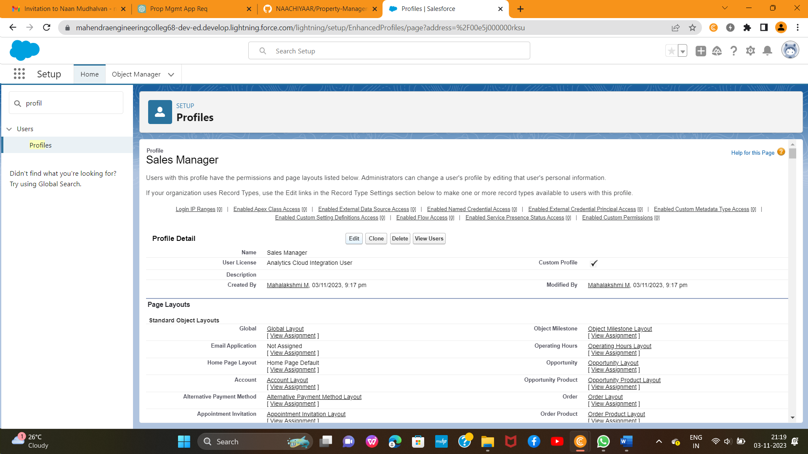

5. Scroll down to Custom Object Permissions and Give view all access permissions for Enquiry, Property, Loan and save(Sales Manager also Having **Create, Edit, Delete** for **Enquiry, property, loan objects**)

